CL A S S & OB J E C T
Md. Shafqat Talukder Rakin
Lecturer, Department of CSE,
United International University
Email id : shafqat@cse.uiu.ac.bd
Acknowledged: Tanjina Helaly
C O N T E N T
🞆 Class & Object.
🞆 Initializing Fields/Instance variables. 🞆 Scope & Lifetime of Variable. 🞆 Arrays
🞆 Parameter Passing
🞆 Garbage Collection
🞆 Package
🞆 Access Modifier
🞆 Recursion
🞆 Variable Argument - vararg
TWO PA R A D I G M S IN OOP
🞆 All computer programs consist of two elements: ⚫ code and data.
🞆 A program can be conceptually organized around its code or around its data.
🞆 That is, some programs are written around “what is happening” and others are written around “who is being affected.”
🞆 These are the two paradigms that govern how an OOP program is constructed.
🞆 In Procedural language data and operation/code are separate
🞆 Example (using C)
⚫ Student – 4 fields: name, id, cgpa, creditCompleted ⚫ Update cgpa – need a function to calculate the new cgpa
CL A S S & OB J E C T
🞆 Object
⚫ An object is a software bundle of related state and behavior.
⚫ Software objects are often used to model the real world objects that you find in everyday life.
🞆 Class
⚫ A class is a blueprint or prototype from which objects are created.
⚫ It defines what should be in each object and how each object should behave.
WHAT IS CL A S S
🞆 the class is the basis for object-oriented programming in Java.
🞆 it defines a new data type.
🞆 Once defined, this new type can be used to create objects of that type.
⚫ Thus, a class is a template for an object,
⚫ and an object is an instance of a class.
⚫ Because an object is an instance of a class, you will often see the two words object and instance used interchangeably
CL A S S ME M B E R S
🞆 Class contains the following 2 members ⚫ instance variables(fields/properties/attributes) 🞆 each instance of the class (that is, each object of the class) contains its own copy of these variables. 🞆 Thus, the data for one object is separate and unique from the data for another.
⚫ Methods(action/behavior)
🞆 The code is contained within methods
🞆 In most classes, the instance variables are acted upon and accessed by the methods defined for that class.
🞆 Thus, as a general rule, it is the methods that determine how a class’ data can be used.
TH E GE N E R A L FO R M O F A CL A S S
class classname {
datatype instance-variable1;
datatype instance-variable2;
/ / ...
datatype instance-variableN;
retyrntype methodname1(parameter-list) {
//body of method
}
returntype methodname2(parameter-list) {
//body of method
}
//...
returntype methodnameN(parameter-list) {
//body of method
}
}
Class Example
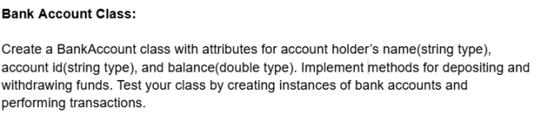
A SI M P L E CL A S S
public class BankAccount {
//Instance variables
public String name;
public String id;
public double balance;
//Methods
public void deposit(double amount){ balance = balance + amount;
}
public void withdraw(double amount){ if (amount<balance)
balance -= amount;
}
}
CR E A T E OB J E C T A N D A C C E S S ME M B E R S
🞆Creating objects – use new keyword ⚫ClassName refVariable = new ClassName(parameter-list);
🞆 To access instance variables and methods - use dot operator(.)
⚫Accessing instance variables
🞆 refVariable.instance_variable = value;
🞆 Or
🞆 datatype value = refVariable.instance_variable;
⚫Calling methods
🞆 refVariable.methodName(parameter-list);
CR E A T E OB J E C T A N D A C C E S S ME M B E R S
public class TestBankAccount {
public static void main(String[] args) {
//C reating objects
BankAccount account = new BankAccount();
//Assigning values to instance variables
account.name = "Rashid";
account.id = “1000500”;
account.balance = 1000;
//Print balance
System.out.println(“Balance before deposit: " + account.balance);
//C alling methods
account.deposit(2000);
//Print balance
}
}
Output:
System.out.println(“Balance after deposit: " + account.balance);
Balance before deposit: 1000.0 Balance after deposit: 3000.0
CR E A T E OB J E C T A N D A C C E S S ME M B E R S public class TestBankAccount {
public static void main(String[] args) { //C reating objects
BankAccount account = new BankAccount(); //Assigning values to instance variables
Use “new” keyword to create object
account.name = "Rashid"; account.id = “1000500”; account.balance = 1000;
//Print balance
Use “dot operator” (.) to access attributes and methods.
}
}
Output:
System.out.println(“Balance before deposit: " + account.balance);
//C alling methods
account.deposit(2000);
//Print balance
System.out.println(“Balance after deposit: " + account.balance);
Balance before deposit: 1000.0 Balance after deposit: 3000.0
RE F E R E N C E VA RI A BLE
BankAccount account;
account
account = new BankAccount();
^{account} reference ^{name = null} id = null
balance = 0.0
account.name = “Rashid”;
account.id = “1000500”;
account.balance = 1000;
^{account} reference ^{name = Rashid} id = 1000500
balance = 1000
CR E A T E OB J E C T A N D A C C E S S ME M B E R S
public class TestBankAccount {
public static void main(String[] args) {
//C reating objects
BankAccount accountR = new BankAccount();
BankAccount accountK = new BankAccount();
//Assigning values to instance variables
accountR.name = "Rashid";
accountR.balance = 1000;
accountK.name = "Kashem";
accountK.balance = 1000;
//C alling methods
accountK.deposit(2000);
//Print balance of both account
System.out.println("Kashem's balance: " + accountK.balance);
}
}
System.out.println("Rashid's balance: " + accountR.balance);
Output:
Kashem's balance: 3000.0 Rashid's balance: 1000.0
RE F E R E N C E VA RI A BLE
Before deposit
^{accountR} reference ^{name = Rashid} id = null
balance = 1000.0
^{accountK} reference ^{name = Kashem} id = null
balance = 1000.0
After deposit: accountR
reference^{name = Rashid} id = null
balance = 1000.0
^{accountK} reference^{name = Kashem} id = null
balance = 3000.0
INITIALIZING FIELDS/INSTANCE VA RI A BLES
INITIALIZING FI E L D S
🞆 There are three ways in Java to give a field an initial value:
⚫ Direct Assignment
⚫ Instance Initialization Block
⚫ Constructors
1.DIRECT AS S I G N M E N T
public class BankAccount {
//Instance variables
public String name;
public String id;
public double balance = 100.0; //direct assignment
//Methods
public void deposit(double amount){
balance = balance + amount;
}
public void withdraw(double amount){
if (amount<balance)
balance -= amount;
}
}
2.INSTANCE INITIALIZATION B L O C K
🞆 Instance initialization blocks are indicated by blocks of code inside the class, but outside any method. 🞆 Whenever an object is created from a class the code in each instance initialization block is executed. 🞆 If there is more than one instance initialization block they are executed in order, from top to bottom of the class.
🞆 Use initialization blocks when the initialization cannot be done in a simple assignment and needs no extra input parameters.
🞆 Direct assignment and constructors are used far more often than initialization blocks.
2.INSTANCE INITIALIZATION B L O C K
public class BankAccount {
//Instance variables
public String name;
public String id;
public double balance;
//Methods
public void deposit(double amount){
balance = balance + amount;
}
public void withdraw(double amount){
if (amount<balance)
balance -= amount;
}
{ //Instance Initialization Block
id = new Random().nextInt(99999) + "";
balance = 100.0;
}
}
3.CO N S T RU C T O R
🞆 A constructor
⚫ Allocate space for instance variables.
⚫ initializes an object(its instance variables) immediately upon creation.
🞆 Syntax:
⚫ It has the same name as the class.
⚫ syntactically similar to a method.
🞆 Except has no return type. Not even void.
🞆 This is because the implicit return type of a class’ constructor is the class type itself.
3.CO N S T RU C T O R
🞆 When called:
⚫ No explicit call
⚫ It is automatically called when the object is created, before the new operator completes.
🞆 What should go inside Constructor
⚫ Normally the instance variables are initialized inside the constructor.
Or
⚫ any set-up code
3.CO N S T RU C T O R - EX A M P L E
import java.util.Random;
public class BankAccount {
//Instance variables
public String name;
public String id;
public double balance;
//Constructor without parameter
public BankAccount(){
id = new Random().nextInt(99999) + "";
//name and balance will get default value
}
//Constructor with parameter
public BankAccount(String _name, String _id, double _balance){ name = _name;
id = _id;
balance = _balance;
}
public static void main(String[] args)
{
BankAccount ba = new BankAccount(“Rashid”, “1000500”, 1000.0); }
}
3.DEFAULT CO N S T R U C T O R
🞆 When you do not explicitly define a constructor for a class, ⚫ then Java creates a default constructor for the class. ⚫ This is why the first BankAccount class code worked even though that did not define a constructor.
🞆 The default constructor automatically initializes all instance variables to their default values,
⚫ Default value
🞆 Boolean -> false;
🞆 All primitive except boolean -> 0 (zero)
🞆 Reference type -> null
🞆 Once you define your own constructor, the default constructor is no longer used.
“THIS”KEYWORD
🞆 refer to the current object.
🞆 That is, this is always a reference to the object on which the method was invoked. 🞆 You can use this anywhere a reference to an object of the current class’ type is
permitted.
CO N S T R U C T O R - EX A M P L E
import java.util.Random;
public class BankAccount {
//Instance variables
public String name;
public String id;
public double balance;
//Constructor without parameter
public BankAccount(){
id = new Random().nextInt(99999) + "";
//name and balance will get default value
}
//Constructor with parameter
public BankAccount(String _name, String _id, double _balance){ name = _name;
id = _id;
balance = _balance;
}
public static void main(String[] args)
{
BankAccount ba = new BankAccount(“Rashid”, “1000500”, 1000.0); }
}
CO N S T R U C T O R - EX A M P L E
import java.util.Random;
public class BankAccount {
//Instance variables
public String name;
public String id;
public double balance;
//Constructor without parameter
public BankAccount(){
id = new Random().nextInt(99999) + "";
//name and balance will get default value
}
//Constructor with parameter
public BankAccount(String name, String id, double balance){ name = name;
id = id;
balance = balance;
}
public static void main(String[] args)
{
BankAccount ba = new BankAccount(“Rashid”, “1000500”, 1000.0); }
}
CO N S T R U C T O R - EX A M P L E
import java.util.Random;
public class BankAccount {
//Instance variables
public String name;
public String id;
public double balance;
//Constructor without parameter
public BankAccount(){
id = new Random().nextInt(99999) + "";
//name and balance will get default value
}
//Constructor with parameter
public BankAccount (String name, String id, double balance) { name = name;
id = id;
balance = balance; }
Variable on left is the same as right What are we doing here
Which variables we are referring to
public static void main(String[] args)
{
BankAccount ba = new BankAccount(“Rashid”, “1000500”, 1000.0); }
}
CO N S T R U C T O R - EX A M P L E
import java.util.Random;
public class BankAccount {
//Instance variables
public String name;
public String id;
public double balance;
//Constructor without parameter
public BankAccount(){
id = new Random().nextInt(99999) + "";
//name and balance will get default value
}
//Constructor with parameter
public BankAccount(String name, String id, double balance){ this.name = name;
this.id = id;
this.balance = balance;
}
public static void main(String[] args)
{
BankAccount ba = new BankAccount(“Rashid”, “1000500”, 1000.0); }
}
Spring 2024 Question 1
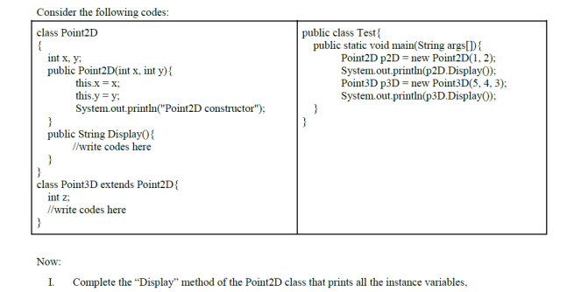
Spring 2024 Question 1
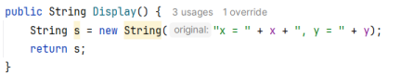
Spring 2024 Question 3
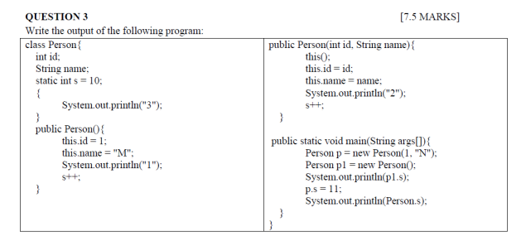
Spring 2024 Question 3
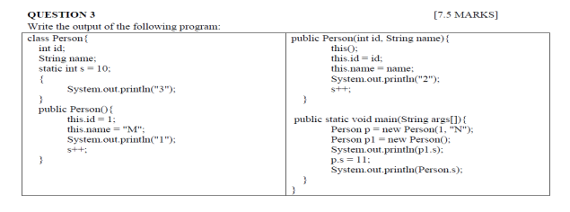Output
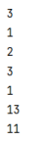
Fall 2023 Question 1
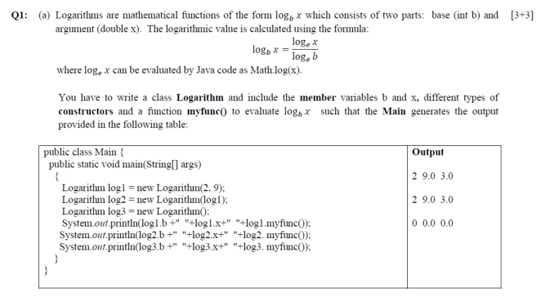
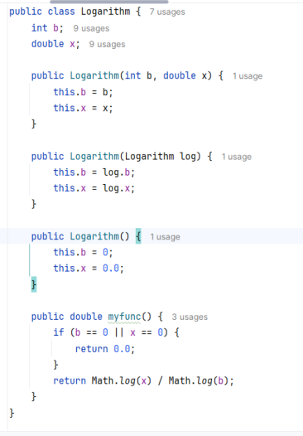
Fall 2023 Question 2
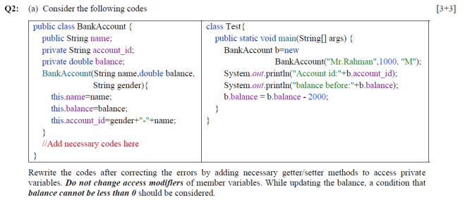
Fall 2023 Question 2
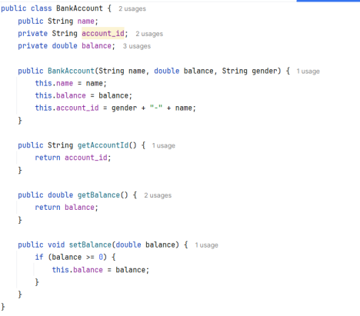
Static and Final
Static Variables
🞆 When a member (both methods and variables) is declared static, it can be accessed before any objects of its class are created, and without reference to any object.
🞆 Static variable
🞆 Instance variables declared as static are like global variables.
🞆 When objects of its class are declared, no copy of a static variable is made.
Static Methods & Blocks
🞆 Static method
🞆 They can only call other static methods. 🞆 They must only access static data.
🞆 They cannot refer to this or super in anyway. 🞆 Static block
🞆 Initialize static variables.
🞆 Get executed exactly once, when the class is first loaded.
Example
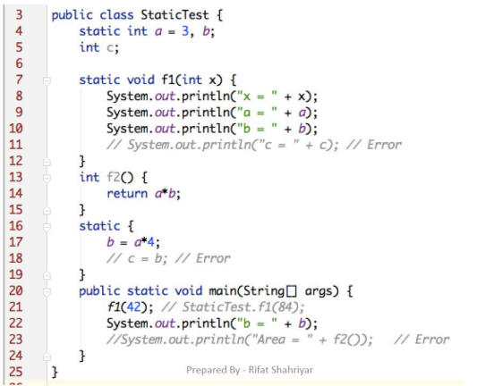
Final
🞆 Declare a final variable, prevents its contents from being modified.
🞆 Final variable must initialize when it is declared. 🞆 It is common coding convention to choose all uppercase identifiers for final variables
🞆 final int FILE_NEW = 1;
🞆 final int FILE_OPEN = 2;
🞆 final int FILE_SAVE = 3;
🞆 final int FILE_SAVEAS = 4;
🞆 final int FILE_QUIT = 5;
SCOPE & LI F E T I M E O F VA R I A B L E S
SCOPE O F VA RI A BLE
🞆 What is scope?
⚫ A scope determines what variable are visible to other parts of your program. Or where the variable is accessible?
⚫ It also determines the lifetime of those variable.
🞆 A block defines a scope.
⚫ the statements between opening and closing curly braces. 🞆 As a general rule, variables declared inside a scope are not visible (that is, accessible) to code that is defined outside that scope.
🞆 Within a block, variables can be declared at any point, but are valid only after they are declared.
⚫ Thus, if you define a variable at the start of a method, it is available to all of the code within that method.
⚫ Conversely, if you declare a variable at the end of a block, it is effectively useless, because no code will have access to it.
SCOPE O F VA RI A BLE - EX A M P L E
public void calculateInterest(double balance) {
if(balance > 10000)
{
float interest = 0.05f;
}
else
{
interest = 0.02f;
}
}
SCOPE O F VA RI A BLE - EX A M P L E
public void calculateInterest(double balance) {
if(balance > 10000)
{
float interest = 0.05f; //Scope of this variable is only inside the if block
}
else
{
interest = 0.02f; //compiler error. interest is declared inside the if block, hence can't access in else block
}
}
🞆 To make “interest” accessible to both if and else block it has to be declared outside of the block.
SCOPE O F VA RI A BLE - EX A M P L E
public void calculateInterest(double balance) {
float interest; //accessible to anywhere inside the method. if(balance > 10000)
{
interest = 0.05f; //Ok
}
else
{
interest = 0.02f; //OK
}
}
SCOPE O F VA RI A BLE
🞆 Many other computer languages define two general categories of scopes:
⚫ global and local.
🞆 However, these traditional scopes do not fit well with Java’s strict, object-oriented model.
🞆 In Java, the two major scopes are
⚫ those defined by a class and
⚫ those defined by a method.
WH E N CAN 2 V A RI A BLES H A V E S A M E
NA M E
🞆 Instance variable and Local variable.
🞆 Local variable in 2 different methods.
🞆 2 Local variables in the same methods but only after the death of one Local variable.
O K  public void calculateInterest(double balance) {  if(balance > 10000){  float interest = 0.05f; // OK  }  else {  float interest = 0.02f; // OK  }  } | Wrong  public void calculateInterest(double balance) {  float interest;  if(balance > 10000){  float interest = 0.05f; // Compiler error }  else {  interest = 0.02f; // OK  }  }

ARRA Y S
ARRA Y AG A I N
🞆 What is the “new” keyword during array creation. 🞆 Is Array variable reference type?
int[] sampleArray = new int[10];
ARRA Y AG A I N
🞆 What is the “new” keyword during array creation. 🞆 Is Array variable reference type?
int[] sampleArray = new int[10];
0
0
0
1
0
0
0
^{simpleArray} reference
0
0
0
0
8
0
9
ARRA Y AG A I N
🞆 When an array is created, each element will be initialized to its default value.
🞆 What is the initial value for each of the element of the arrays below.
⚫ int[] sampleArray = new int[10];
⚫ Student[] students = new Student[10];
RE F E R E N C E TY P E WITH NO T NU L L Student student = new Student(“Rashid”, “011153001”, 3.0f, 50);
^{student} reference^{name = Rashid}
id = 011153001
cgpa= 3.0f
creaditCompleted = 50
🞆 What value will you get when you access the following attributes of student reference variable/object.
⚫ student.name
⚫ student.id
⚫ student.cgpa
⚫ student.creditCompleted
RE F E R E N C E TY P E WITH N U L L
Student student = null;
^{studen} null ^{t}
🞆 What value will you get when you access the following attributes of student reference variable/object. ⚫ student.name
⚫ student.id
⚫ student.cgpa
⚫ student.creditCompleted
RE F E R E N C E TY P E WITH N U L L
🞆 We cant access any member via the reference variable when no object is created.
🞆 Accessing the member will throw NullPointerException.
RE F E R E N C E TY P E ARRA Y
🞆 Example
Student[] students = new Student[3];
System.out.println(students[0].cgpa); //What would be the output of this line.
null
students reference
null null
RE F E R E N C E TY P E ARRA Y
🞆 Need to initialize the element before accessing. 🞆 Example
Student[] students = new Student[3];
students[0] = new Student(“Rashid”, “011153001”, 3.0f, 50);
students[1] = new Student(“Zaman”, “011153021”, 3.0f, 50);
students[2] = new Student(“Lubna”, “011153031”, 3.5f, 50);
System.out.println(students[0].cgpa); //What would be the output of this line.
name = Rashid
id = 011153001
cgpa= 3.0f
students reference
Ref Ref Ref
creaditCompleted = 50
name = Lubna
id = 011153031
cgpa= 3.5f
creaditCompleted = 50
name = Zaman
id = 011153021
cgpa= 3.0f
creaditCompleted = 50
PA RA MET ER PA S S I N G
PA R A M E T E R PA S S I N G
🞆 2 different ways
⚫ Pass By Value
⚫ Pass By Reference
🞆 In J av a all parameters are passed by value
PA S S B Y RE F E R E N C E – NO T A P P L I C A BL E FO R J AVA
🞆 Send the location of the parameter. 🞆 Original value chage
🞆 C , C++, php
main() {
int i = 10, j = 20;
cout << i << " " << j << endl;
swapThemByRef(i, j);
cout << i << " " << j << endl; //displays 20 10 ...
}
void swapThemByRef(int& num1, int& num2) {
int temp = num1;
num1 = num2;
num2 = temp;
}
PA S S B Y RE F E R E N C E – NO T A P P L I C A BL E FO R J AVA
🞆 Send the location of the parameter. 🞆 Original value chage
🞆 C , C++, php
main() {
int i = 10, j = 20;
cout << i << " " << j << endl;
swapThemByRef(i, j);
cout << i << " " << j << endl; //displays 20 10 ...
}
void swapThemByRef(int& num1, int& num2) { int temp = num1;
num1 = num2;
num2 = temp;
}
Output: 10 20
20 10
PA S S B Y RE F E R E N C E
🞆 At the beginning of function call i ₁₀ ₂₀ j
num1 num2 temp
🞆 After the function execution. i ₂₀ ₁₀ j
^{num1 num2}₁₀ temp
PA S S B Y VA L U E
🞆 Send a copy of the original parameter. 🞆 Original value does not change 🞆 Example:
main() {
int i = 10, j = 20;
cout << i << " " << j << endl;
swapThemByVal(i, j);
cout << i << " " << j << endl;
}
void swapThemByVal(int num1, int num2) {
int temp = num1;
num1 = num2;
num2 = temp;
}
PA S S B Y VA L U E
🞆 Send a copy of the original parameter. 🞆 Original value does not change 🞆 Example:
main() {
int i = 10, j = 20;
cout << i << " " << j << endl;
swapThemByVal(i, j);
cout << i << " " << j << endl; //displays 20 10 ... }
void swapThemByVal(int num1, int num2) {
int temp = num1;
num1 = num2;
num2 = temp;
}
Output: 10 20
10 20
PA S S B Y VA L U E
🞆 At the beginning of method call i ₁₀ ₂₀ j
₁₀ ₂₀ num1 num2 temp
🞆 After the method execution. i ₁₀ ₂₀ j
₂₀ ₁₀ ^{num1 num2}₁₀ temp
PA S S B Y VA L U E
🞆 Java Example:
public class PassByValue {
public static void main(String[] args) { int a=10, b=20;
System.out.printf("a-%d:b-%d\n", a, b); swapThemByVal(a, b);
System.out.printf("a-%d:b-%d\n", a, b); }
Output:
a-10:b-20
a-10:b-20
static void swapThemByVal(int num1, int num2) { int temp = num1;
num1 = num2;
num2 = temp;
}
}
PA S S B Y VA L U E
🞆 At the beginning of method call i ₁₀ ₂₀ j
₁₀ ₂₀ num1 num2 temp
🞆 After the method execution. i ₁₀ ₂₀ j
₂₀ ₁₀ ^{num1 num2}₁₀ temp
PA S S B Y VA L U E – WITH OB J E C T
🞆 When an object is passed to a method, the situation changes dramatically,
🞆 Java will pass by value but the effect will be like pass-by-reference.
🞆 Why?
⚫ When we create a variable of a class type, it will store the reference to an object.
⚫ Thus, when the value of the variable will be passed to a method, it will pass the reference of the same object.
⚫ This effectively means that objects act as if they are passed to methods by use of pass-by-reference. ⚫ Changes to the object inside the method do affect the object used as an argument.
PA S S B Y VA L U E – WITH OB J E C T
public class Test{
String testName;
float score;
Test(String n, float s){
testName = n;
score = s;
}
void display(){
System.out.printf("TestName: %s ; Score: %.2f \n", testName, score);
}
}
PA S S B Y VA L U E – WITH OB J E C T
public class PassByValue {
public static void main(String[] args) {
Test t = new Test("CT1", 10);
t.display();
updateScore(t, 15.0f);
System.out.println("After Update:");
t.display();
}
static void updateScore(Test test, float newScore) { test.score = newScore;
}
}
Output:
TestName: CT1 ; Score: 10.00
After Update:
TestName: CT1 ; Score: 15.00
PA S S B Y VA L U E – WITH OB J E C T
🞆 Before the method call
t
reference
Object
testName= “CT1” score = 10.0f;
🞆 At the beginning of method call
⚫ Both “t” and “test” are referring to the same object.
⚫ Updating the object using any variable will be reflected in the other one.
t _{reference} _{reference} test
testName= “CT1” score = 10.0f;
🞆 Just at the end of method execution – before exiting the method
t _{reference} _{reference} test
testName= “CT1” score = 15.0f;
GA R B A G E CO L L E C T I O N
GA R B A G E CO L L E C T I O N
🞆 when no references to an object exist, that object is assumed to be no longer needed, and the memory occupied by the object can be reclaimed.
🞆 Garbage collection only occurs sporadically (if at all) during the execution of your program. 🞆 Different Java run-time implementations will take varying approaches to garbage collection, 🞆 but for the most part, you should not have to think about it while writing your programs.
GA R B A G E CO L L E C T I O N – SCENARIO#1
BankAccount accountR = new BankAccount(“Rashid”, “1000500” , 1000.0); BankAccount accountK = new BankAccount((“Kashem”, “1000501” , 10000.0);
Heap
Stack
name = Rashid
id = 1000500
balance = 1000.0
^{accountR} reference
^{accountK} reference ^{name = Kashem} id = 1000501
balance = 10000.0
GA R B A G E CO L L E C T I O N – SCENARIO#1
BankAccount accountR = new BankAccount(“Rashid”, “1000500” , 1000.0); BankAccount accountK = new BankAccount((“Kashem”, “1000501” , 10000.0); accountR = accountK;
//Rashid’s object can no longer be accessed and is eligible for garbage collection Heap
Stack
name = Rashid
id = 1000500
balance = 1000.0
^{accountR} reference
^{accountK} reference ^{name = Kashem} id = 1000501
balance = 10000.0
GA R B A G E CO L L E C T I O N – SCENARIO#2
BankAccount accountR = new BankAccount(“Rashid”, “1000500” , 1000.0); BankAccount accountK = new BankAccount((“Kashem”, “1000501” , 10000.0);
Heap
Stack
name = Rashid
id = 1000500
balance = 1000.0
^{accountR} reference
^{accountK} reference ^{name = Kashem} id = 1000501
balance = 10000.0
GA R B A G E CO L L E C T I O N – SCENARIO#2
BankAccount accountR = new BankAccount(“Rashid”, “1000500” , 1000.0); BankAccount accountK = new BankAccount((“Kashem”, “1000501” , 10000.0); accountR = null;
//Rashid’s object can no longer be accessed and is eligible for garbage collection Heap
Stack
name = Rashid
id = 1000500
balance = 1000.0
^{accountR} null
^{accountK} reference ^{name = Kashem} id = 1000501
balance = 10000.0
GA R B A G E CO L L E C T I O N – SCENARIO#3
public class TestMain{
public static void main(String[] args) {
updateScore(new Test("CT1", 10), 15.0f);
}
static void updateScore(Test test, float newScore) {
test.score = newScore;
}
}
public class Test{
String testName;
float score;
Test(String n, float s){
testName = n;
score = s;
}
}
GA R B A G E CO L L E C T I O N – SCENARIO#3 🞆 At the beginning of method call
reference ^{test} testName= “CT1” score = 10.0f;
🞆 After exiting the method.
⚫ “test” variable will no longer be available.
⚫ The Test object can no longer be accessed and is eligible for garbage collection
testName= “CT1”
score = 15.0f;
HeapHeap

